Project Database Report



**Abraham Foto**

**557797**

**SasmitaThije**

**552301**

**Louis Lee**

**559942**

**ShamilKarimli**

**523001**



Project Database

IBIS website advisory report

May 21, 2015

Author: Amadeus Inc.



# **Preface**

Am



A relational database is a digital database whose organization is based on the relational model of data, as proposed by E.F.Codd in 1970. In this report you can find a brief description of the website created for IBIS students and also a description of the database created for the client. Database is an integrated and organized collection of logically related records or files or data that are stored in a computer system which consolidates records previously stored in a separate files into a common pool of data records that provides data for many applications.

# **Table of Contents**

**Preface** 4

**Table of Contents** 5

Summary 6

List of terms 7

List of abbreviation and symbols 8

Chapter 1: Introduction................................................................................................................................5

**Chapter 2: Strategy .............................................................................................................................6**

Chapter 3: Database Description ............................................................................................................10

3.1 Step 1: Filtering the nouns, Transforming into...................................................................................14

3.2 Step 2: Removing all Singletons..........................................................................................................14

3.3 Step 3: Definition of the Statements....................................................................................................14

3.4 Step 4: Removing double and vague statements ............................................................................15

3.5 Step 5: Constructing tables .......................................................................................................... 16

3.6 Step 6: E-R Diagrams .................................................................................................................... 17

Chapter 4: Website Description.................................................................................................................18

Chapter 5: Git ............................................................................................................................................14

Chapter 6: Bibliography............................................................................................................16

Conclusions...........................................................21

Drawings..............................................................22

Bibliography..........................................................23

Appendix..............................................................24

# 

# Summary

This report marks the completion of the final phase of the Project Database. This project was intended to create a database and a website for the IBIS Department of InHolland University of Applied Sciences.

# The first phase of the Project Database consisted of making a scratch for the database design and for the website interface. The stages of creating a database scratch are documented in this report. A new database system was proposed by team Amadeus. All necessary normalization steps and code samples are included into this report.

All reference and resource can be found at the end of this report on Bibliography.

# List of terms

2.1 Database Terms (General)

|  |  |
| --- | --- |
| Term | Description |
| Atributtes | A single data item related to a database object. The database schema associates one or more attributes with each database entity. |
| Client | A client-side process, containing proxy functions, connecting to a server process that contains the actual database functions |
| Collumn | A single unit of named data that has a particular data type (e.g., number, text, or date). Columns only exist in tables. |
| Commit | The action that causes the all of the changes made by a particular transaction to be reliably written to the database files and made visible to other users. |
| Conceptual model | A conceptual data model identifies the highest-level relationships between the different entities. |
| Connection | The means of communication between a client and a server. A process may have multiple connections opened, each in its own thread, to one or more databases at a time |
| Constraints | used to specify rules for the data in a table. |
| Data | Distinct pieces of information |
| Data integrity | Data integrity refers to maintaining and assuring the accuracy and consistency of data over its entire life-cycle, and is a critical aspect to the design, implementation and usage of any system which stores, processes, or retrieves data |
| Data type | The basic kind of data that can be stored in a column. The data types that are available in RDM SQL are: char, wchar, varchar, wvarchar, binary, varbinary, boolean, tinyint, smallint, integer, bigint, real, float, double, date, time, timestamp, long varbinary, long varchar, and  long wvarchar. |
| Database | an integrated and organized collection of logically related records or files or data that are stored in a computer system which consolidates records previously stored in a separate files into a common pool of data records that provides data for many applications. |
| DBMS | An acronym for DataBase Management System |
| DDL | Database Definition Language |
| DML | Database Manipulation Language. In SQL, such statements as UPDATE, INSERT and DELETE are considered DML |
| Entity | an entity is some unique unit of data that can be classified and have stated relationships to other entities |
| E-R model | a data model for describing the data or information aspects of a business domain or its process requirements, in an abstract way that lends itself to ultimately being implemented in a database such as a relational database. |
| Foreign key | One or more columns in a table intended to contain only values that match the related primary/unique key column(s) in the referenced table. |
| Index | A separate structure that allows fast access to a table’s rows based on the data values of the columns used in the index. |
| Key | A column or columns on which an index is constructed to allow rapid and/or sorted access to a table’s row |
| Logical model | A logical data model describes the data in as much detail as possible, without regard to how they will be physical implemented in the database. |
| Normalization | The process of reducing redunancy in the tables of the database |
| Physical model | Physical data model represents how the model will be built in the database. A physical database model shows all table structures, including column name, column data type, column constraints, primary key, foreign key, and relationships between tables. |
| Primary key | A column or group of columns in a given table that uniquely identify each row of the table. The primary key is used in conjunction with a foreign key in another (or even the same) table to related the two tables together. |
| Query | A complete SELECT statement that specifies 1) the columns and tables from which data is to be retrieved, 2) optionally, conditions that the data must satisfy, 3) optionally, computations that are to be performed on the retrieved column values, and 4) optionally, a desired ordering of the result set. |
| Rollback | An operation, usually performed by the SQL ROLLBACK statement, that discards all of the changes made by all INSERT, UPDATE and DELETE statements that have been executed since the most recently started transaction |
| Server | Database server is the term used to refer to the back-end system of a database application using client/server architecture. The back-end, sometimes called a database server, performs tasks such as data analysis, storage, data manipulation, archiving, and other non-user specific tasks. |
| SQL | The standardized and commonly accepted language used for defining, querying and manipulating a relational database. |
| Table | A collection of closely related columns. A table consists of rows each of which shares the same columns but vary in the column values |
| Transactions | A set of logically related database modifications that are written to the database as a unit. |
| Tuples | A finite ordered list of elements |

2.2 Web Interface Terms

|  |  |
| --- | --- |
| Term | Description |
| Browser | A Client software program that is used to look at various kinds of Internet resources. eg Internet explorer, Netscape Navigator |
| Download | Transferring data from one computer to another computer which you are using. The opposite of uploading |
| File extension | A tag of usually threee letters which identifies the format of the file, so that programs will recognise it and be able to open it. Eg ".doc" a document file |
| Homepage | Originally, the web page that a browser is set to use when it starts up. Now the most common meaning refers to the main web page for a website, also called the index page or default page. |
| Host | Any computer on a network that is a repository for services available to other computers on the network such as SMTP for email and HTTP for web |
| Interface | The interaction between a user and software running on a Web server. The user interface is the Web browser and the Web page it downloaded and rendered |
| PHP | An open source, server-side, HTML embedded scripting language used to create dynamic Web pages. In an HTML document, PHP script is enclosed within special PHP tags enabling the author to jump between HTML and PHP, similar to active server pages. PHP is executed on the server, so the client cannot view the code. |
| Session | A session is a way to store information (in variables) to be used across multiple pages |
| Upload | The transfer of files, data or documents from a the computer you are using to another computer. The opposite of download |
| Website design | A general term to describe everything visible on the pages of a website, and includes navigation, site architecture, page structure, positioning of text and image and the use of multimedia |
| Website navigation | The ability to find and move from one page to another. |

# List of abbreviation and symbols

|  |  |
| --- | --- |
| Abbreviation | Definition |
| DDL | Data Definition Language |
| DML | Data Manipulation Language |
| SQL | Structured Query Language |
| DBMS | Database management Language |
| ER | Entity Relationship |
| DB | Database |
| API | Application Program Interface |
| HTML | Hypertext Markup Language |
| PHP | Personal Home Page Hypertext Preprocessor |

# Chapter 1: Introduction

1. Problem statement

The International Business Innovation Studies (IBIS) program is Inholland's new challenging, fully international English-taught 4-year full-time bachelor program. It is aimed at providing the business world and society with agents of innovation who can help the business they work for to survive and thrive in this age of rapid change.Following the educational philosophy of the program that people are more motivated to learn when they have a say in what they learn and how, students will be able to create 60 EC of their study programthemselves by choosing from a wide array of Negotiated Learning units. With these Negotiated Learning Units students create their own specializations within the overarching graduate profile of international business innovator in combination with their chosen graduation track. The Negotiated Learning Units are broadly related to international business innovation, but also allow students to venture into other, related, areas of interest.

To enroll for this negotiated curriculum, student needs to go personally to the administration office to enroll for the negotiated course. The administration office have to do the enrollment procedure manually, which means by paper and pen. In this way, the administration office doesn’t have any digital database and digital application or software to make the enrollment simpler. The other disadvantage is that it is consume a lot of time and human resource. Moreover, some of the courses schedule might overlap with another’s. Consequently, it makes it more difficult to check if a student can enroll for particular course without overlapping with other courses that he already enrolled.

Taking these disadvantages to consideration, the client, Sandra Reeb-Gruber (Curriculum Director of IBIS), requested to make a web-based application for the negotiated curriculum enrollment. In which the administration office can keep track of all enrolledstudents, their grades and all of the negotiated courses being offered. With this web-based application, the students also can enroll themselves online.

1. Research objectives

To build a PHP based web-application for administration office which can keep track of the offered courses, student enrollment, student’s grade and checking overlap course. With this web-application, we hope that students also get the benefits.

To build a database for negotiated curriculum enrolment which is integrated and organized collection of logically related records or files or data that are stored in a computer system which consolidates records previously stored in a separate files into a common pool of data records that provides data for many applications.

# Chapter 2: Strategy

By the end of this project, the administration office should be able to get all the advantages of a database and a web-application have to offer. Therefore the negotiated curriculum enrolment procedure should not cost as much as it does now.

1. Research methodology ?

* Strategy  
  A plan of action designed to achieve a certain high-level goal
* Tactics  
  A plan containing concrete steps to achieve a well-defined singular goal
* Operations  
  The executing of the tactical plan
* Research design
  + Quantitative
  + Qualitative
* Research units
  + Population
  + Sample
* Research constructs
  + Operationalization

# Chapter 3: Database Description

**Step 1:**

|  |  |  |  |  |
| --- | --- | --- | --- | --- |
| Client | Place | External | Time | courses |
| System | Time | Tech | registrationData | system |
| Courses | Location | Question | registration | database |
| registration | Course | Interface | Staff | courses |
| Courses | Subject | Administrators | member | morning |
| employees | fieldOfStudy | System | system | phase |
| Students | Employee | Courses | courses | attachment |
| numberOfLessons | Internal | Dates | Term | student |

|  |  |  |  |  |
| --- | --- | --- | --- | --- |
| Student | Brief | Lesson | Moment | Course |
| Database | App | Contact | Time | Whole |
| Students | Money | Moment | Course | Lesson |
| Inholland | Time | Course | Group | Course |
| Account | Week | Teacher | Students | divisions |
| Information | Person | Students | Capacity | Room |
| Relevant |  | Course | Terms | Number |
| App | EUR | Lessons | Number | example |

|  |  |  |  |  |
| --- | --- | --- | --- | --- |
| Room | Example | Course | Else | Idea |
| Number | Other | Somewhere | Building | Talk |

**Step 2:**

Fillter all singletrons

- database

- system

- question

- InHolland

- EUR

- Money

- App

- Example (?)

-other (?)

- Idea (?)

- else

**Step 3:**

Define the statements which are left

|  |  |  |
| --- | --- | --- |
| Client | An end user |  |
| Courses | The lesson being taught |  |
| Registration | Inserting a value into the database |  |
| Courses | The lesson being taught |  |
| Employees | People working for the company |  |
| Students | Individuals receiving an education |  |
| numberOfLessons | Number of classes being taught |  |
| Place | Geographical location |  |
| Time | Number of hours on the clock |  |
| Location | /Similar to place |  |
| Course | The lesson being taught |  |
| Subject | Narrow topic covered during the lecture |  |
| fieldOfStudy | Specific field in which research is being held |  |
| Employee | Person working for the company |  |
| Internal | Person inside the company |  |
| External | Person outside of the company , hired for a limited period of time |  |
| Tech | Technology related topic |  |
| Question | A formulated thought for questioning |  |
| Interface | The way information connects to the user |  |
| Administrators | The person or a machine executing the task of a manager for the department |  |
| Courses | The lesson being taught |  |
| Dates | Dates of the classes |  |
| Time | The [indefinite](http://www.oxforddictionaries.com/definition/english/indefinite#indefinite__2) continued progress of existence and events in the past, present, and future regarded as a [whole](http://www.oxforddictionaries.com/definition/english/whole#whole__9) |  |
| registrationData | Data required to register |  |
| registration | Taking the subject from the field of unknown into field of known |  |
| Staff | Personnel |  |
| Member | An active participant of the society |  |
| Courses | The lesson being taught |  |
| Term | Specific period of time usually taking 8-10 weeks |  |
| Courses | The lesson being taught |  |
| Courses | The lesson being taught |  |
| Morning | Period of time from 6 AM to 11:59 AM |  |
| Phase | Proportiona period of time in which action is being held |  |
| Attachment | Banderole |  |
| Student | Individual receiving an education, alumni |  |
| Student | Individual receiving an education, alumni |  |
| Students | Individuals receiving an education, alumnus |  |
| Account |  |  |
| Information | A packet of auditory,visual, intuitive symbols which are kept together |  |
| Relevant | i.e relevant to to the topic, being relevant |  |
| App | A structure proceding a task |  |
| Brief | A set of [instructions](http://www.oxforddictionaries.com/definition/english/instruction#instruction__8) given to a person about a job or task |  |
| App | A structure proceding a task |  |
| Money | An active participant of the society |  |
| Time | Number of hours on the clock |  |
| Week | 7 days |  |
| Person | An individual |  |
| Lesson | The narrow subject which is concentrated upon during the class |  |
| Contact | A person in the contact list |  |
| Moment | A specific piece of time |  |
| Course | The lesson being taught |  |
| Teacher | An individual delivering the content of the subject |  |
| Students | Individuals receiving an education |  |
| Course | The lesson being taught |  |
| Lessons | The narrow subject which is concentrated upon during the class |  |
| Moment | A specific piece of time |  |
| Time | The [indefinite](http://www.oxforddictionaries.com/definition/english/indefinite#indefinite__2) continued progress of existence and events in the past, present, and future regarded as a [whole](http://www.oxforddictionaries.com/definition/english/whole#whole__9) |  |
| Course | The lesson being taught |  |
| Group | Some amount of people following some task together |  |
| Students | Individuals receiving an education |  |
| Capacity | The maximum possible amount of entity which can a can hold |  |
| Terms | Specific period of time usually taking 8-10 weeks |  |
| Number | An [arithmetical](http://www.oxforddictionaries.com/definition/english/arithmetic#arithmetic__2) [value](http://www.oxforddictionaries.com/definition/english/value#value__10), expressed by a word, [symbol](http://www.oxforddictionaries.com/definition/english/symbol#symbol__2), or figure, representing a particular quantity and used in [counting](http://www.oxforddictionaries.com/definition/english/count#count__2) and making [calculations](http://www.oxforddictionaries.com/definition/english/calculation#calculation__2): |  |
| Course | A specific collection of classes constructed in order to deliver the main context in most appropriate way |  |
| Whole | Tao |  |
| Lesson | The narrow subject which is concentrated upon during the class |  |
| Course | A specific collection of classes constructed in order to deliver the main context in most appropriate way |  |
| Divisions | Part of the whole( i.e divisions of military) |  |
| Room | Some space limited by walls in a specific geographic location |  |
| Number | An [arithmetical](http://www.oxforddictionaries.com/definition/english/arithmetic#arithmetic__2) [value](http://www.oxforddictionaries.com/definition/english/value#value__10), expressed by a word, [symbol](http://www.oxforddictionaries.com/definition/english/symbol#symbol__2), or figure, representing a particular quantity and used in [counting](http://www.oxforddictionaries.com/definition/english/count#count__2) and making [calculations](http://www.oxforddictionaries.com/definition/english/calculation#calculation__2): |  |
| Example | An imaginary model of something |  |
| Room | Some space limited by walls in a specific geographic location |  |
| Number | An [arithmetical](http://www.oxforddictionaries.com/definition/english/arithmetic#arithmetic__2) [value](http://www.oxforddictionaries.com/definition/english/value#value__10), expressed by a word, [symbol](http://www.oxforddictionaries.com/definition/english/symbol#symbol__2), or figure, representing a particular quantity and used in [counting](http://www.oxforddictionaries.com/definition/english/count#count__2) and making [calculations](http://www.oxforddictionaries.com/definition/english/calculation#calculation__2): |  |
| Example | An imaginary model of something |  |
| Course | A specific collection of classes constructed in order to deliver the main context in most appropriate way |  |
| Somewhere | In a random place of a choise |  |
| Building | A collection of rooms |  |
| Idea | An abstract value |  |
| Talk | An abstract value |  |

**Step 4:**

Clean from double statements

|  |  |  |  |
| --- | --- | --- | --- |
| Client | External | Attachment | Teacher |
| Courses | Tech | Student | Lessons |
| Registration | Question | Capacity | Divisions |
| Course | Interface | Terms | Room |
| Employees | Administrators | Account | Number |
| Students | Dates | Information | Building |
| Number Of Lessons | Registration Data | Relevant | Idea |
| Place | Staff | App | Talk |
| Time | Member | Brief | Whole |
| Location | Term | Money | Example |
| Subject | Lesson | Week | Somewhere |
| Field Of Study | Morning | Contact |  |
| Employee | Internal | Moment |  |
| Phase | Person | Group |  |

cleaning from vague statements

|  |  |  |  |
| --- | --- | --- | --- |
| Client | External | Attachment | Number |
| Courses | Tech | Student | Building |
| Registration | Question | Capacity | Lessons |
| Course | Interface | Terms | Divisions |
| Employees | Administrators | Account | Room |
| Students | Dates | Brief | Morning |
| Number Of Lessons | Registration Data | Week | Internal |
| Place | Staff | Contact | Person |
| Time | Member | Moment | Field Of Study |
| Location | Term | Group | Employee |
| Subject | Lesson | Teacher | Phase |

**Step 5:**

Client Student

-first_name - ID

-last_name - first_name

-email - last_name

- postcode -email

- ID - address

- postcode

Course Group

* Registration - student
* Employees Person
* Students -ID
* Number_Of_Lessons - first_name
* Time -last_name
* Schedule -postcode
* Staff - address
* Member -phone_nr
* Capacity

Employee

-ID

- first_name

- last_name

- address

- email

- postcode

**Step 6:**

1 ,Er diagram version1 : Er model for employee only. Employee entity is didiveded into twoo internal Employee and external Employee.

2,Er diagram version 2: a person tables is created as mister haralldrecommanded. and the sudent table and Employee table are created with thierrelation ship to employee

3, Er diagram version 3: All the tables are connected in Er model , tables are : person, student, employee , internal and external employees.

4 , Er diagram version 4: Additional table is created for the ternary relation ship between student , grade and registration,

4b, Er diagram version 5: final er model.

5 Er diagram version 6: gerneral representation of thge model

6,Er diagram version 7:( logical model) identifable and nonidentifable relationships are

7, Er diagram version 8: table division is added the to the relation

8, Er diagram version 9: phone number is deleted as attribute of an employee

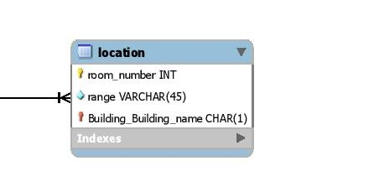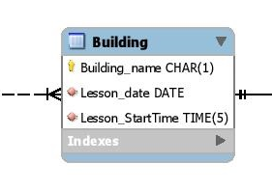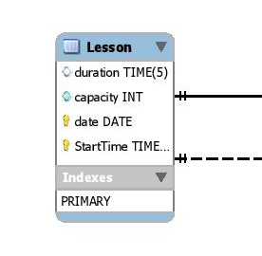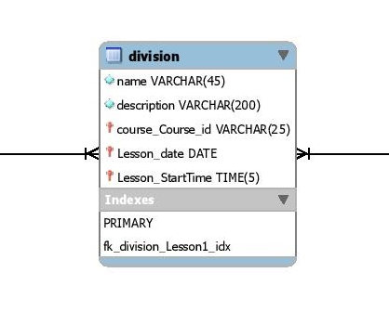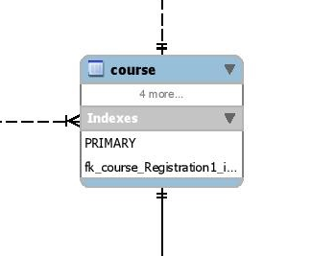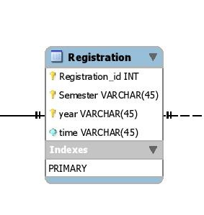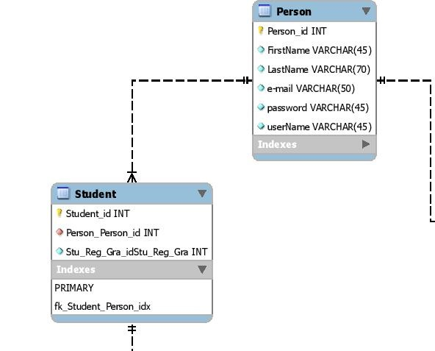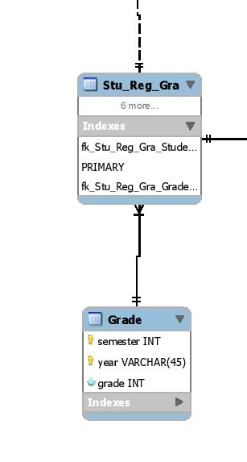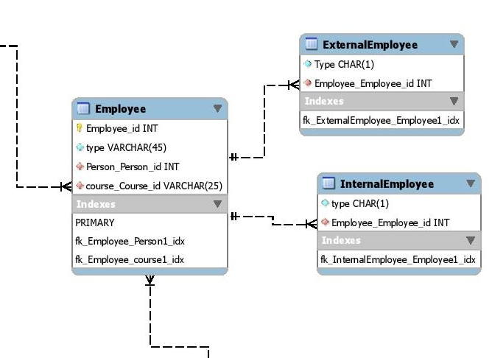

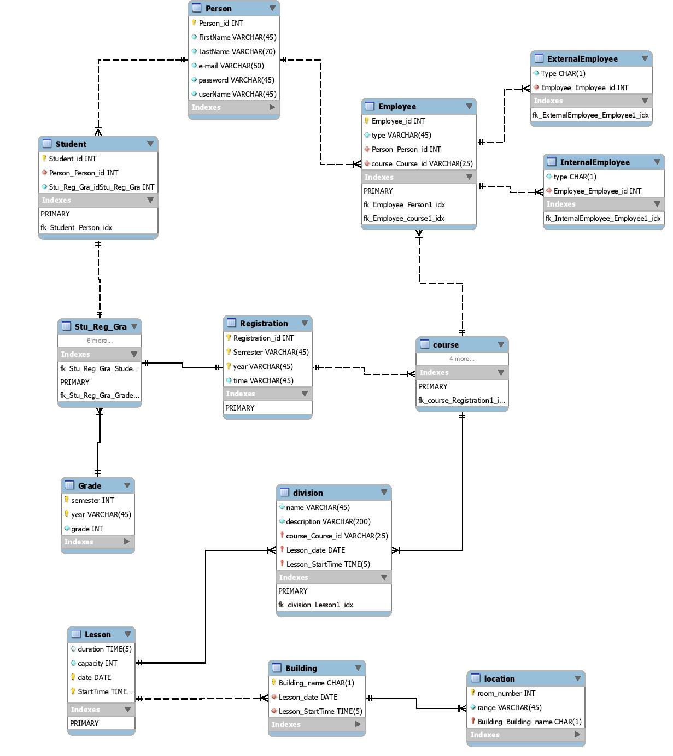

# Chapter 4: Website Description/ User Interface

4.1: User Interface, User Instructions

SETUP PHP:

1 - OPEN /website/include/database.php

2 - EDIT username and password for your MySQL server

3 - MOVE /website TO HTDOCS

SETUP DATABASE:

1 - OPEN inholland.sql

2 - COPY all the text in it

3 - PASTE it in MySQL cmd

4 - PRESS enter

TO RUN:

1 - OPEN /website in web browser

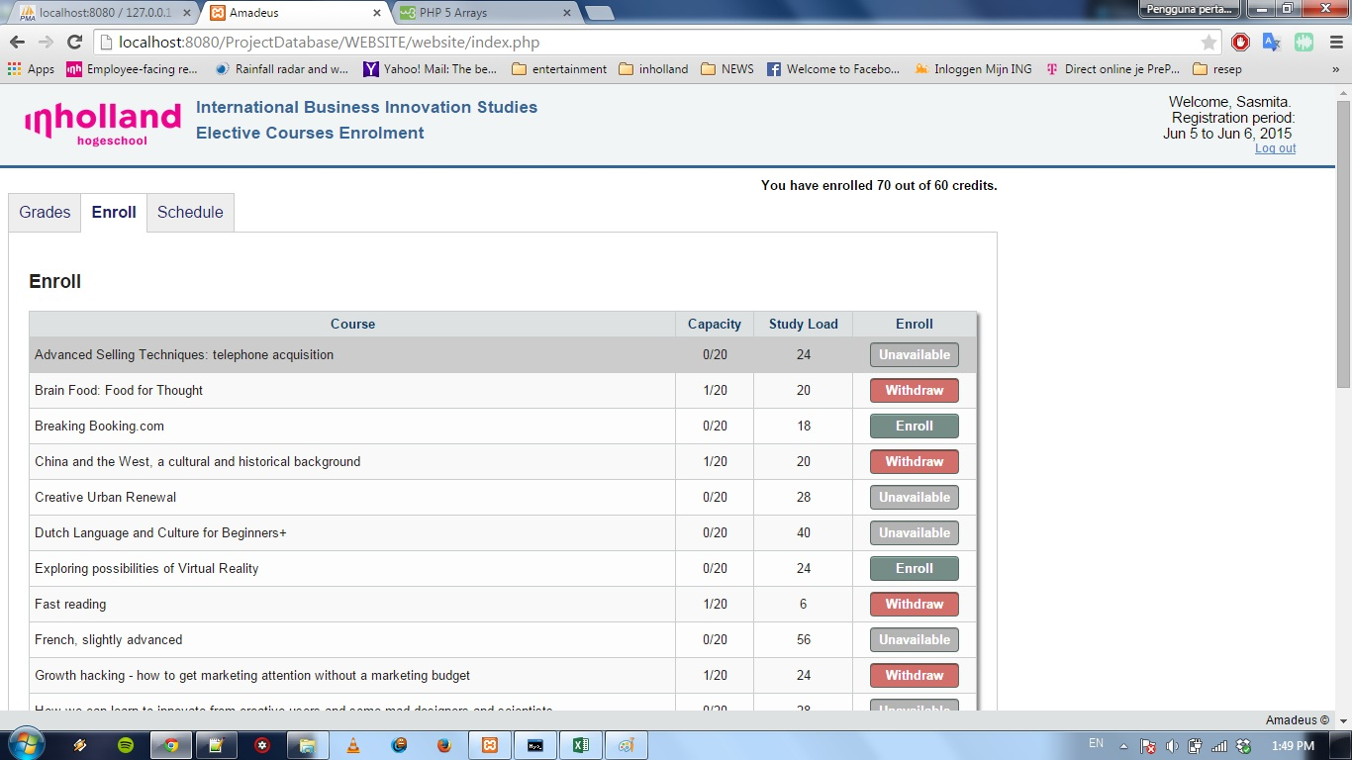

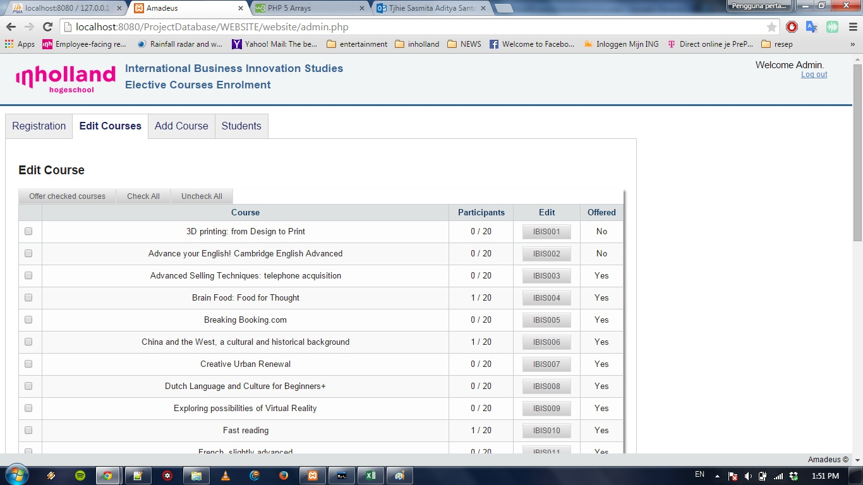

4.2: Code

//website interface

<?PHP

////////dbconnnect

$user_name = "root";

$pass_word = "sasmita";

$database = "inholland";

$server = "127.0.0.1";

$connection = new mysqli($server, $user_name, $pass_word, $database

/////////Gets specific result from query

function mysqli_result($res, $row, $field = 0)

{ $res->data_seek($row);

$datarow = $res->fetch_array();

return $datarow[$field]; }

# Chapter 5: Git

# Bibliography

<http://raima.com/database-terminology/>

about.com

Wikipedia.com

<http://www.1keydata.com/datawarehousing/physical-data-model.html>

w3school.com

<http://www.pcmag.com/encyclopedia/term/60249/web-interface>

http://en.wikipedia.org/wiki/Relational_database

# Appendix